OFFICE OF THE UNIVERSITY CONTROLLER

standard operating procedures

accounting for SERVICE CENTERS & CORE FACILITIES
  - July 1, 2023

Table of Contents
1. Types of Service Center/Core Facility Internal Charging Units
2. Purpose of Service Center/Core Facility Charging
3. Characteristics of Service Centers/Core Facilities
4. Types of Cross-Unit Internal Expense Transactions
5. Rate Calculations
6. Recording Service Centers/Core Facilities Charges
7. Accounting Requirements for Service Centers/Core Facilities
8. Creating a New Service Center/Core Facility & Other Internal Charging Considerations
9. Contact for Questions

Types of Service Center/Core Facility Internal Charging Units
The University categorizes service center & core facility units using the following descriptions:
Recharge Unit – A Recharge Unit is an operating unit established to provide goods and services to the university community, including externally sponsored awards, internal departments, and (incidentally) external customers. Units of this nature are usually non-academic and their annual activity does not exceed $25,000. Recharge Unit internal user rates will only include direct costs associated with providing the services for internal users (including sponsored awards). External user rates will include direct & indirect costs.
Service Center/Research Core Facility – A Service Center is an operating unit established to provide goods and services to the university community, including externally sponsored awards, internal departments, and (incidentally) external customers. Academic units of this nature are also sometimes referred to as “Core Facilities.” Service Center rates will only include direct costs associated with providing the services for internal users (including sponsored awards) and annual activity will exceed $25,000. External user rates will include direct & indirect costs.

Specialized Service Facilities – Specialized Service Facilities (SSF) are “Service Center” facilities that provide highly complex/specialized services and equipment with annual revenues greater than $1,000,000 and significant expenditures to/revenues from federal awards (50% or more). SSF’s additionally are resources that provide equipment, technical and administrative support, repository capabilities, consultation and/or training services in a specific scientific area for a fee to all investigators within the institution and possibly to external constituents.. SSFs will develop rates which include direct, and in some cases indirect costs depending on the type of user, associated with providing the services.

Purpose of Service Center/Core Facility Charging
This procedure outlines how service centers/core facilities charge for goods and/or services to internal and external consumers. The purpose of implementing an accounting procedure is to:
- Define, standardize, and promote the consistent accounting treatment for recording service center/core facility charge transactions across the University, whereby expenses are recorded accurately to ensure that year-end financial statements are precise, and do not double-count expenditures.
- Ensure that service center/core facility internal charge transactions do not increase the total university income or expenses or misstate the operating results of any university department or unit.
- Ensure adherence to Generally Accepted Accounting Principles (GAAP) & compliance with state and federal regulations surrounding revenue and expense transactions at the University.

Characteristics of Service Centers/Core Facilities
The following are the characteristics of Service Centers/Core Facilities:
- Operating units within Rutgers University (RU) that provide goods or services to internal units, externally sponsored awards, and external clients (incidentally) for a fee based on an approved rate schedule
- Offer goods or services on an on-going basis that are unique, convenient, or not readily available from external sources
- Rates designed to recover no more than the aggregate cost of goods or services and break-even over time
- Activities are consistent with the University's mission.
- Activities conducted are not classified as sponsored research, and cannot be used to replace the performance of sponsored research
- Any Activities that are illegal or that violate University, State, Federal, or GAAP policy/guidelines/standards are not permitted.

Users of Service Centers/Core Facilities
Although service centers primarily serve internal users and sponsored awards, external users may incidentally also utilize the centers. These user groups are defined below.
Internal User - A school, department, faculty or staff member of the University that purchases goods or services to support a program or activity at Rutgers. Only direct costs are included in rates/costs for internal users. Internal users include Principal Investigators whose activities are funded by externally sponsored programs to the University, since these programs represent university activities.
External User - An external user is an entity or person with whom the University has no direct affiliation and for which the University has no fiduciary responsibility, and payments will be made from a non-Rutgers funding source. The billing rates for external users must also include indirect costs in addition to the direct costs charged internally. External users can be charged a market rate to prevent potential claims of unfair competition from local businesses. Any resulting surpluses will be used to offset calculated rates in future years.
Before providing goods or services to external users, service centers should consult with the Tax Director within the University Financial Administration (UFA), as some income may be taxable. In addition, service centers that sell goods and services to external users may be engaged in an “unrelated trade or business” as defined by the Internal Revenue Code. Revenues from these activities are may be subject to federal and state income taxes and must be reported by the university on its federal income tax return.

Rate Calculations
Allowable Costs
User fees must be based on and designed to recover no more than the operating costs for the goods or services being provided. Examples of allowable operating costs include:
- Salaries and wages, and applicable university fringe benefit rates
- Supplies and materials
- Capital Equipment maintenance contracts and depreciation
- Other directly-related expenses related to the service provided (e.g., travel, communications)
Unallowable Costs
- Charges included in RCM (Responsibility Center Management) cost allocations, such as facilities expenses for utilities, maintenance, and custodial costs, are paid by the University and not recorded in the operation or service facility account.
- Institute and departmental overhead costs that are not charged to the Fee for Service operation or service facility account.

A service center rate is the cost per unit of goods or services sold set to recover the expenses of the service center and achieve a breakeven financial position. The use of an appropriate billable unit is essential to ensuring that users are charged only their fair share of the actual costs of operating the service center. Rates are based on budgeted projections of operating expenses, including a carryforward surplus/deficit, divided by projected levels of activity or revenue.

Budgeted Expenses +/- Cumulative Carryforward Surplus/Deficit
Budgeted/Projected Level of Sales of Goods/Services (Billable Units)

Billing rates must be reviewed and computed and approved by the UCO at least biennially. The rates should be based on a reasonable estimate of the direct operating costs, and where applicable, indirect costs of providing the services for the year. These estimates can be determined through use of historical costs and billing units or projected costs and billing units. In some cases, the service center may charge a market price, so long as it recovers no more than cost by doing so.

Service Center/Core Facility Charging Guidelines
Service Center/Core Facility charges are to be recorded using the following guidelines:
- Units provide goods and services using designated chart of accounts values for recording an internal charge. The designated account value required for purchasing goods and/or services must be provided on quotes, invoices and any form of communication sent to internal customers.
- The units that consume the goods and services must use the specific account values designated when purchasing goods and/or services.
- The same designated natural account values must be used for the debit and credit sides of the transactions to ensure that the accounts will net to zero for accurate financial reporting.
- The expense requestor and/or approver is responsible for ensuring that the appropriate internal charge natural account value is being used when placing requests.

Accounting Requirements for Service Centers/Core Facilities
The accounting requirements for Service Center/Core Facility operating projects are:
- All Service Centers/Core Facilities must be university entities.
- All Service Centers/Core Facilities must use the natural accounts listed on both the debit and credit side of the transactions to record expenses that are internal.
- All Service Centers/Core Facilities are a Project only Fund Type 155 or 156 (Animal Care only).
- Organization code, when combined with the Unit and Division codes, will make a unique UDO that identifies the Service Centers/Core Facilities.
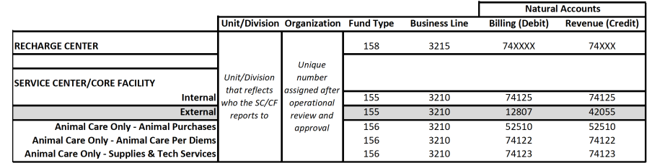

Creating a New Service Center/Core Facility & Other Internal Charging Considerations
Rutgers is a non-profit organization and must not generate a profit. Federal and non-Federal transactions must be charged the same rates.
All rates for internal charging must be reviewed and approved by Cost Analysis & Reporting. Rates are reviewed biennially (every 2-years).
All units processing internal charges to other university units for goods and/or services must first be approved by the UCO.
Project request forms should be completed after the Service Center/Core Facility has been reviewed & approved. Forms should be returned to cost@finance.rutgers.edu. The forms will be reviewed and routed in DocuSign for electronic signature before submission to the UCO Chart of Accounts team for processing.
For sponsored project (Grants and Awards) – No additional administrative fees allowed
To begin the process of creating a service center/core facility, complete the IPO Supplier documents found at https://procurementservices.rutgers.edu/resources/forms. All documents indicated below must be completed and submitted to cost@finance.rutgers.edu for review the review process to begin.
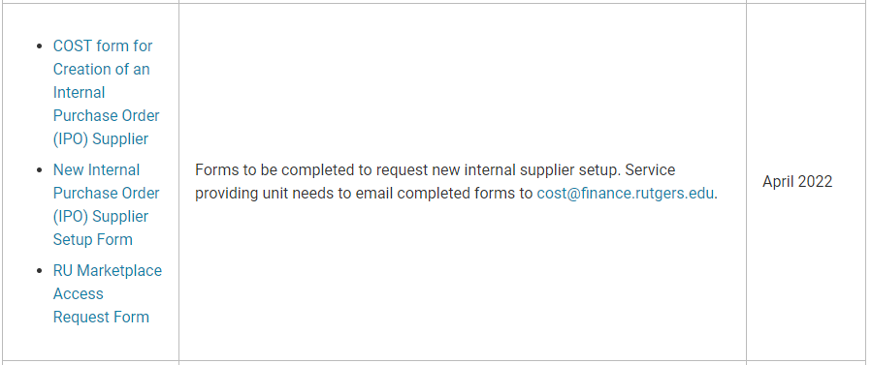
Conversely, academic units can instead inquire with the Office for Research at cores@research.rutgers.edu to begin the initial core facility process or find more information at Become a Core Facility.

Contact for Questions
Please send inquiries or questions regarding Service Centers/Core Facilities to cost@finance.rutgers.edu and/or cores@research.rutgers.edu.

