CAPITAL EQUIPMENT VERIFICATION PROCESS
INTRODUCTION
The Federally mandated Biennial Capital equipment verification process is required to be completed during Fiscal Year 2025. The FY 2025 audit process will incorporate business unit feedback obtained from FY2023 audit, including more time to complete the process, improved reports and additional support. Further, all equipment status codes from FY2023 verification process are reflected in the Oracle Fixed Asset database, reducing the number of FY2025 records to review. (i.e. confirmed retirements, surplus, cannibalized and unfound all removed from database)
The Capital Equipment Team has already started preparing for the FY 2025 verification by reducing the amount of assets for departments to confirm. Already completed audited records will be excluded from your FY2025 inventory report.
To complete this process, you should:
- Verify that the assets are found, and the locations are correct.
- Update the status for each asset. A selection status grid is included at the top of each department report with a drop down in each cell.
Your assigned Capital Equipment team member will contact you in early January 2025 and can assist you with any questions you have.
PROCESS
Step 1: You will receive your department report from your assigned Capital Equipment Team members in early January 2025. An example of the report is provided below.
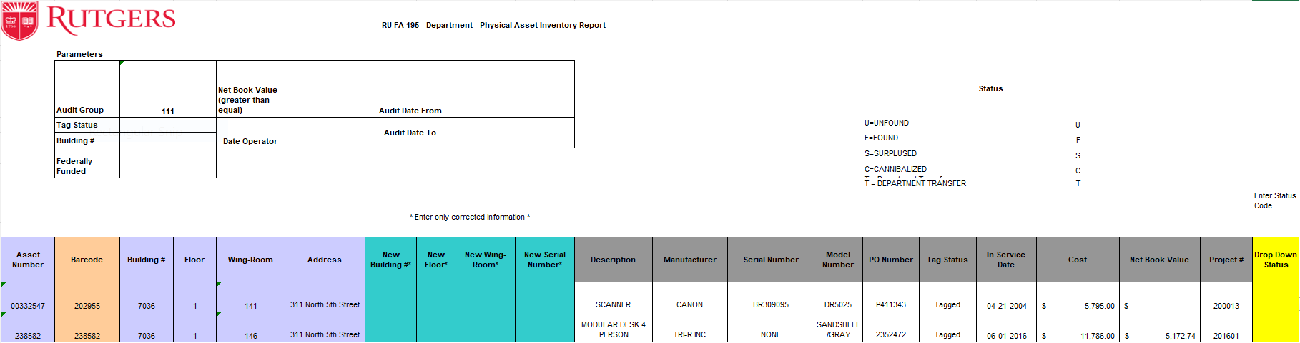
Step 2: If required, filter the data and produce a downloadable Excel file: **
** Any data filled in by different business units, should be transferred to the original form and sent back to the capital equipment team.

Step 3: Choose appropriate status code from the drop down from yellow column U. Status codes can be viewed in the Oracle Fixed Assets database which you can access by visiting. https://finance.rutgers.edu/resource-library/universitywide/forms-and-templates
Step 4: Confirm equipment location is correct in purple cells (C-D). If the location is incorrect then update the new location in the turquoise column (G-I).
Step 5: You may correct or add a missing Serial number in turquoise column J
Step 6: Relevant information or notes can be added to each record in column AA . If the asset is already Tagged with a Property Barcode and shows NOT TAGGED in column P please put TAGGED in the NOTES column AA. See below

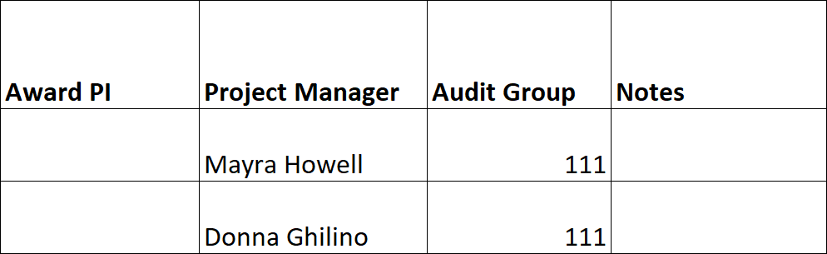

Step 7: Proceed to the next asset until the entire spreadsheet is completed.
Step 8: Each record must have a valid status code. See the appendix for a listing of valid status codes.
Step 9: Email the completed report to both, your assigned Capital equipment team member and the CapitalAssets@finance.rutgers.edu

A: Capital equipment team members:

- Andrew Kvortek – akvortek@finance.rutgers.edu
- Erik Young – ey128@finance.rutgers.edu
- Levi Wilson – lw607@finance.rutgers.edu
- Mike Braswell – mikebb@finance.rutgers.edu
- Bob Fiocco – rjf161@finace.rutgers.edu

APPENDIX A: CAPITAL EQUIPMENT STATUS CODES

FOUND (F) – During an equipment audit the asset is FOUND. The asset might have been found in the current listed location. The asset may also have been found with an Update to the Location, Serial#, or special Notes. This is recorded as an (F) in the Status Code drop down box.

UNFOUND (U) – During an equipment audit the asset is UNFOUND. A list of the assets unfound will be provided to the department Chair/Director to sign off, retiring the assets. This is recorded as a (U) in the Status Code drop down box.

SURPLUSED (S) – When an asset is sent to Material Services Surplus a copy of the Surplus Form should be forwarded to Capitalassets@finance.rutgers.edu at the time the assets are picked- up. The Property Tag# (Barcode) should be listed in the RU TAG# column of the Surplus Form. If not, an asset will still be listed as Active during an equipment audit. This is recorded as an (S) in the Status Code drop down box.

Cannibalized – When an asset is Cannibalized by the department this should be recorded on the C.E.M. Transfer/Disposal form. The Form should be forwarded to Capitalassets@finance.rutgers.edu at the time the asset is Cannibalized. If not, an asset will still be listed as Active during an equipment audit. This is recorded as a (C) in the Status Code drop down box. Provide a completed Transfer/Disposal form.

TRANSFER – When an asset is Transferred by the department to another Rutgers department this should be recorded on the C.E.M. Transfer/Disposal form. The Form should be forwarded to Capitalassets@finance.rutgers.edu at the time the asset is Transferred. If not, an asset will still be listed as Active during an equipment audit. This is recorded as a (T) in the Status Code drop down box. Provide a completed Transfer/Disposal form.

