Step 1: Visit paymybill.rutgers.edu and log in to your online term bill.
OR: Log in to the myRutgers portal and access the OTB via the My Money widget.

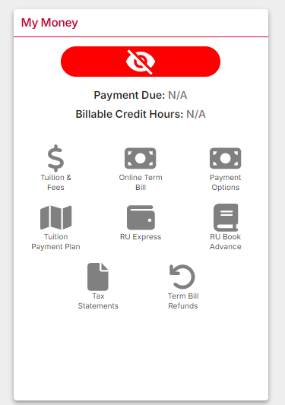

Step 2: Select the appropriate semester. Click the ‘Pay My Bill’ button found under the Outstanding Balance box.

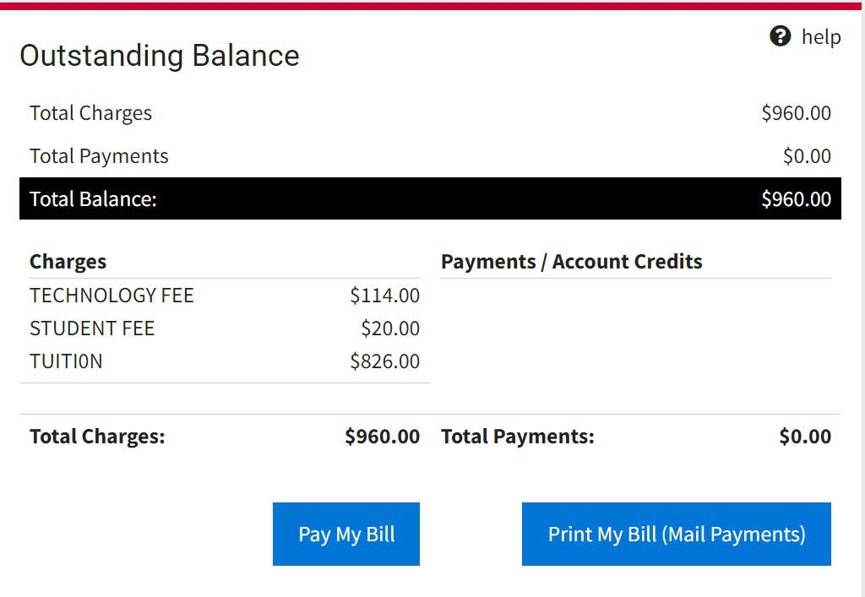

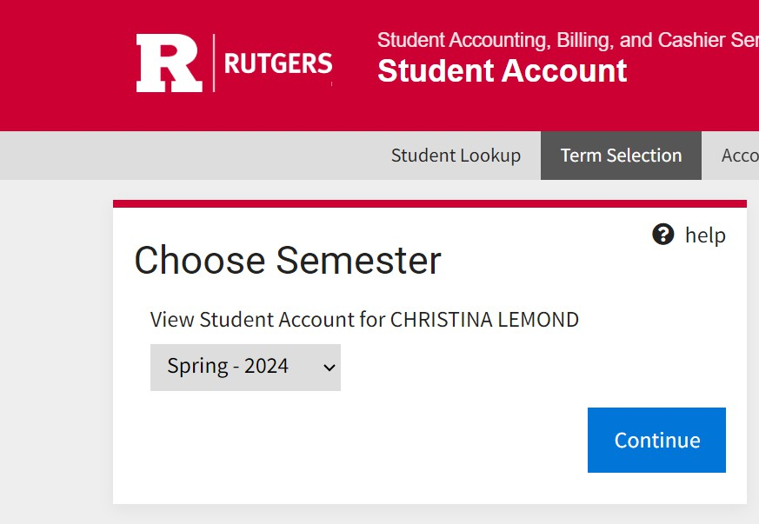

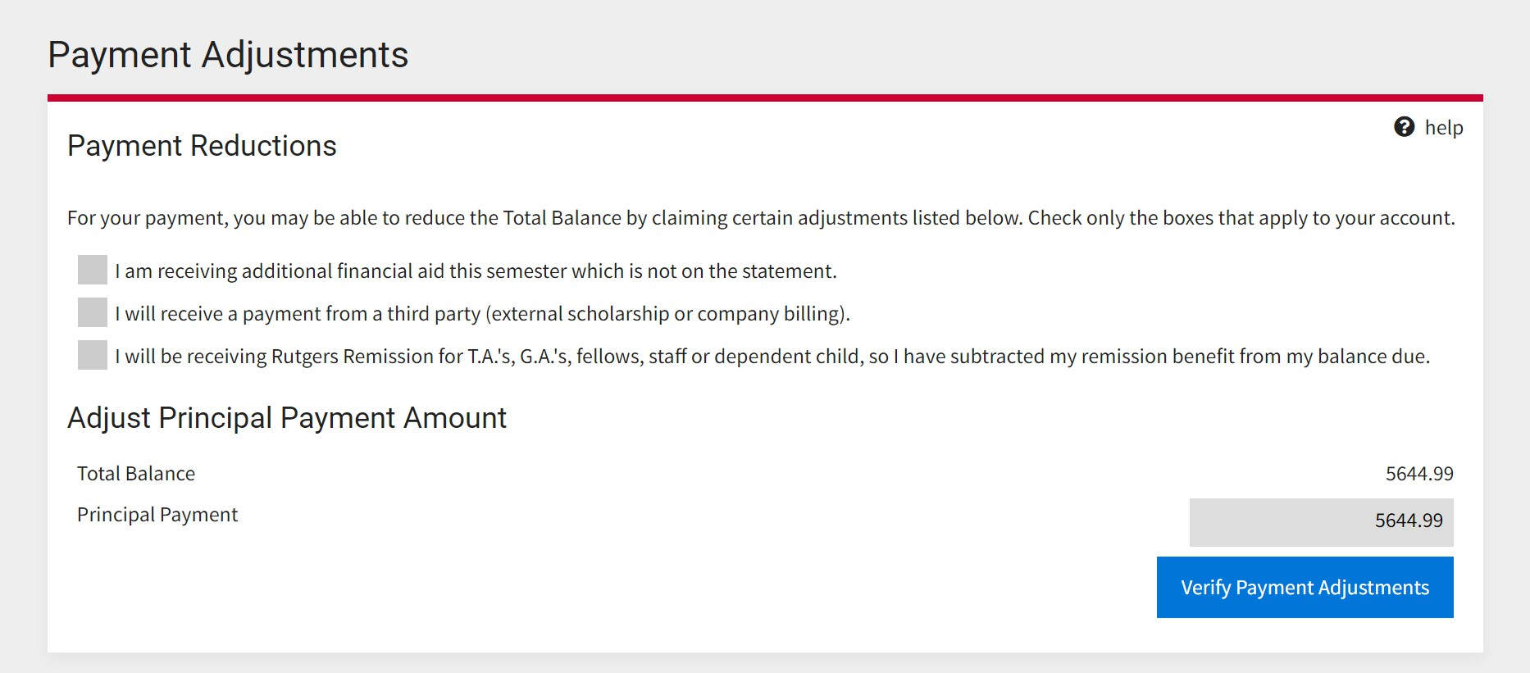

Step 3: On the Payment Adjustments screen, select the ‘Verify Payment Adjustments’ button. You can manually adjust the payment amount in the grey box.
960.00

960.00

Step 4: Select the ‘Continue to Online Payment’ button to continue to Nelnet QuikPAY.

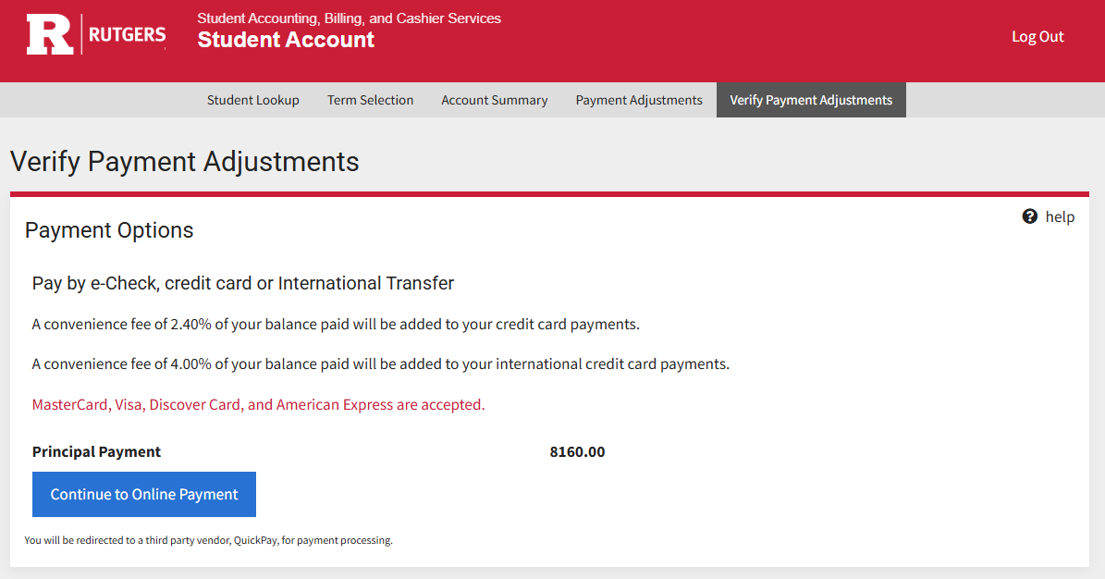

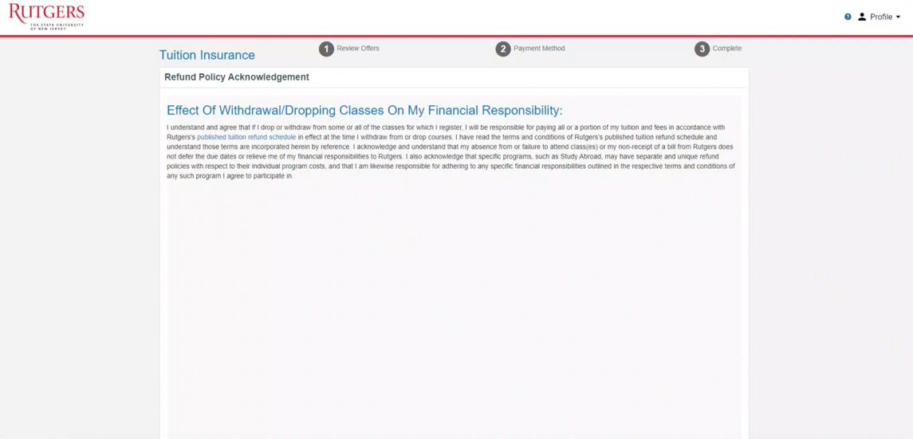
Step 5: You will be prompted to acknowledge the Refund Policy upon accessing the Nelnet QuikPAY portal.
Step 6: You must then review GradGuard Tuition Insurance information and choose to enroll or decline tuition insurance. Students who choose to enroll in Tuition Insurance can view complete instructions here. Tuition insurance can be purchased via e-check and credit or debit card.

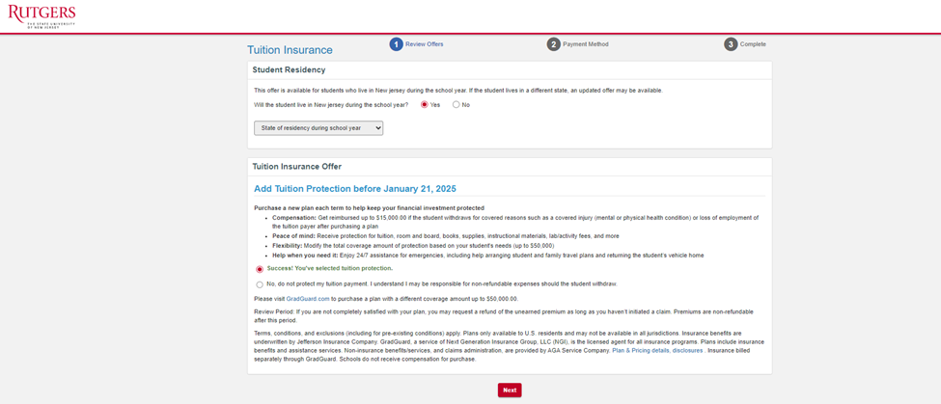

Note: If you decline Tuition Insurance at this time, you can return to the Tuition & Fee Protection tab to enroll before the deadline.

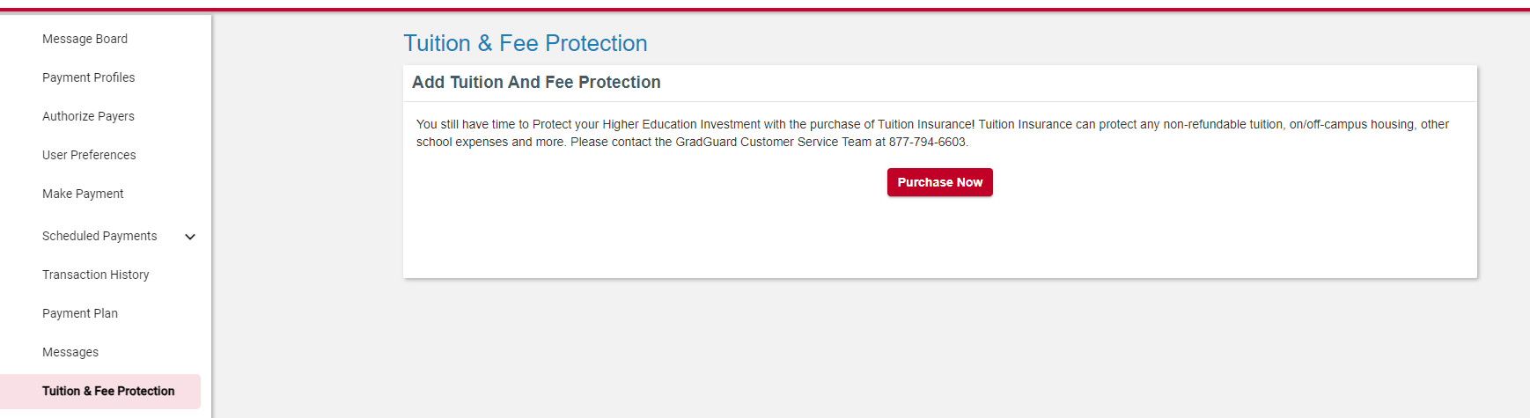
Step 7: Select Credit/Debit as the payment method. Please note that credit and debit cards incur a 2.40% service fee for domestic cards, and a 4.00% service fee for international cards.

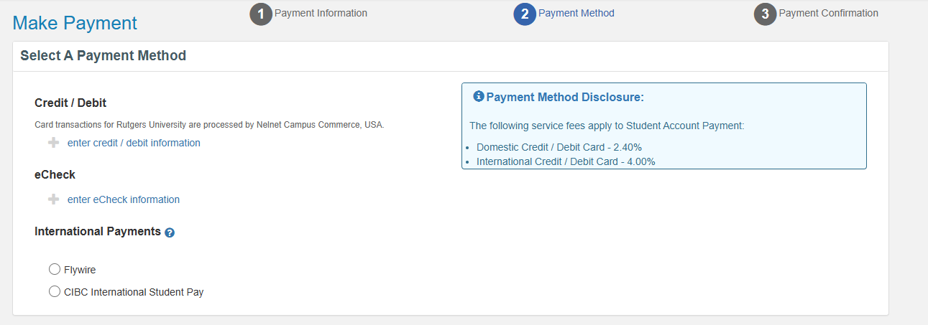

Step 8: Enter the payment information and billing address.

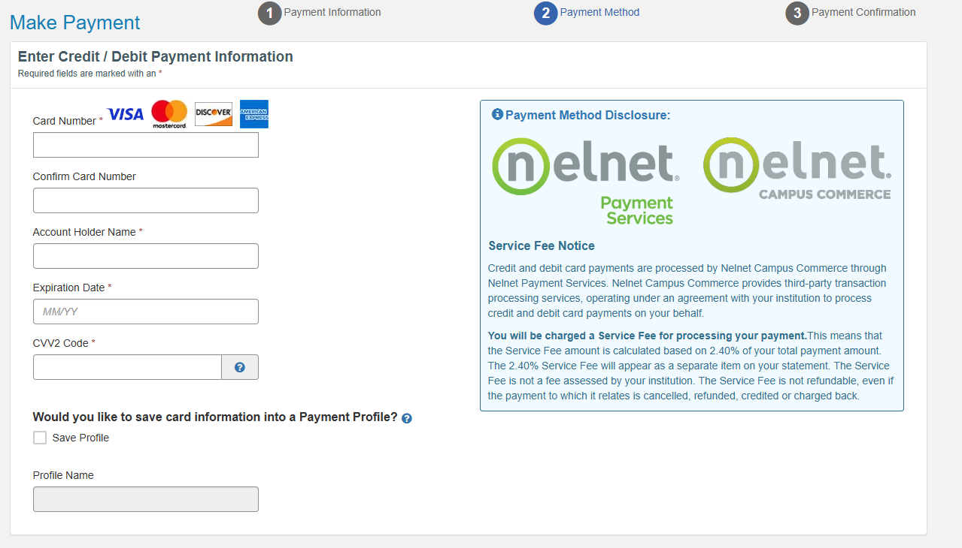

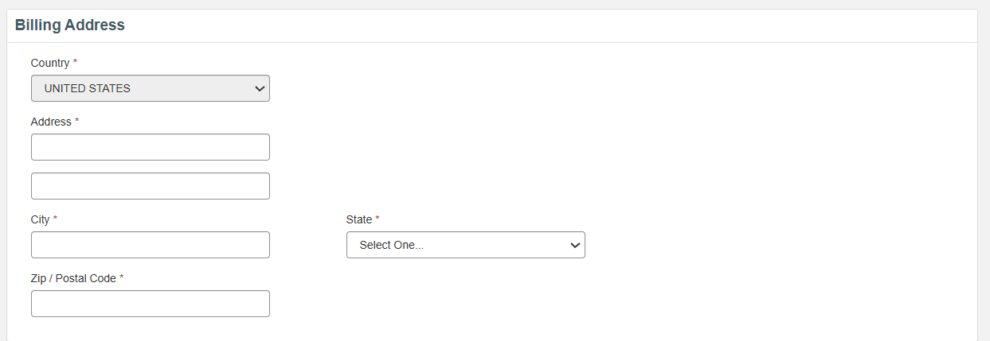
Step 9: Enter your contact information, agree to the service fee, and Submit Payment.

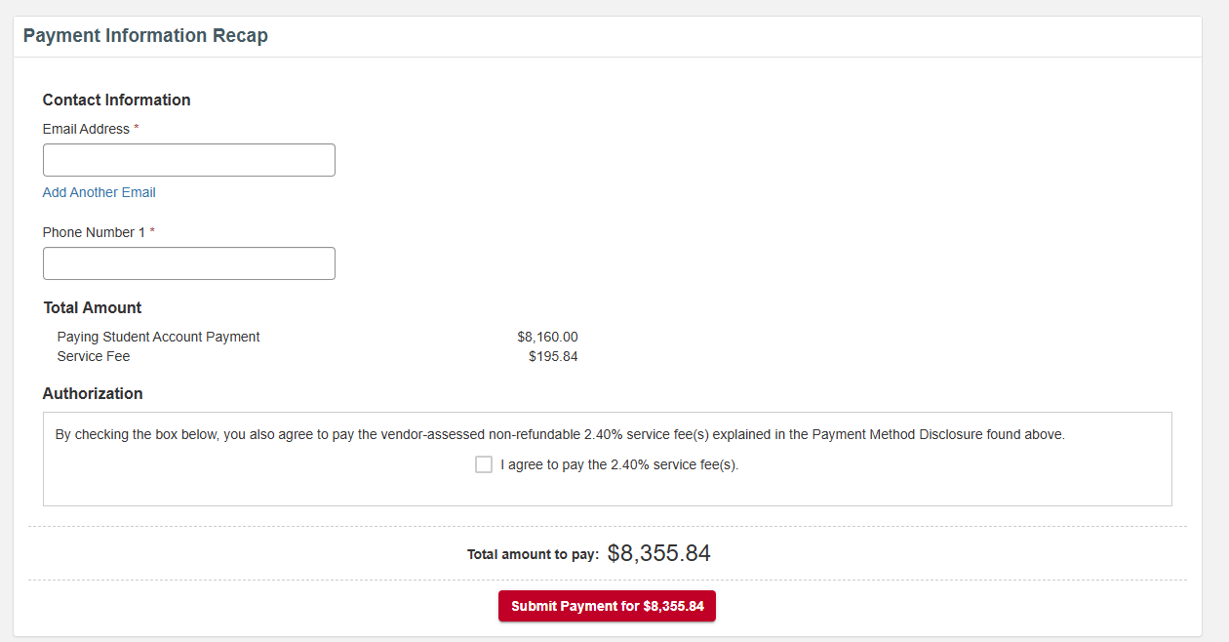
$983.04
$983.04
$983.04
$960.00
$23.04

