- Log in to your myRutgers portal and click the ‘View/Pay Bill’ button under the My Money widget. You will be redirected to Flywire.
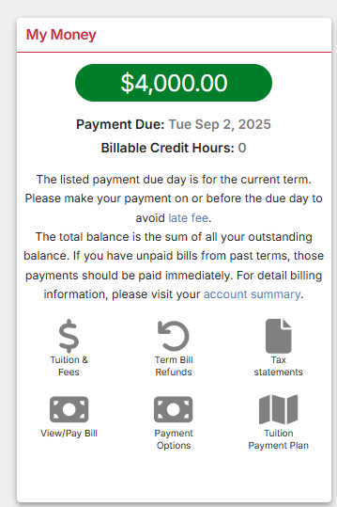
- Review your term bill, including charges, payments, and credits under the Account Activity tab.

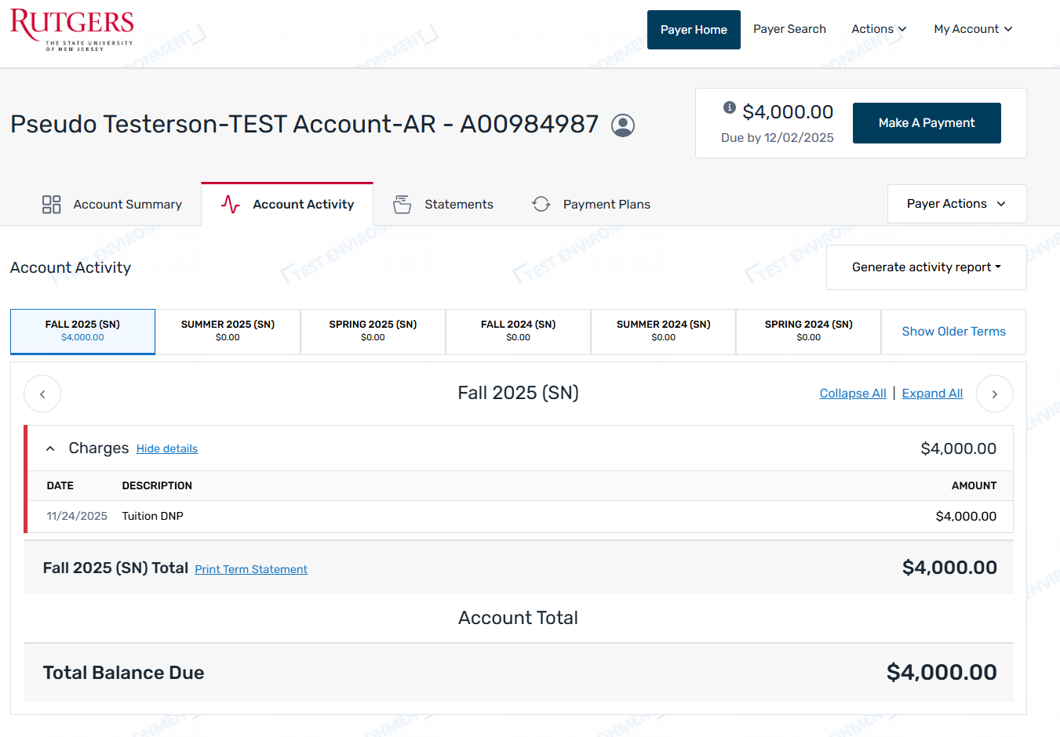

- Click the Make a Payment button.
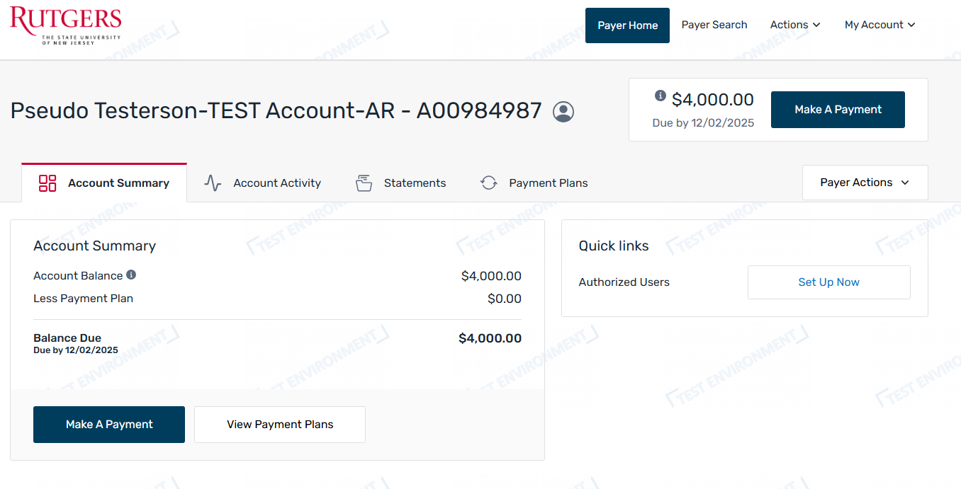
- Choose the term(s) you wish to pay. You can edit the amount you wish to pay and set a payment date. Please note that scheduling a future-dated payment will not prevent past due notices or having an AR hold placed on your account. An AR hold will not be removed until the payment is posted to your account. Then click Continue.
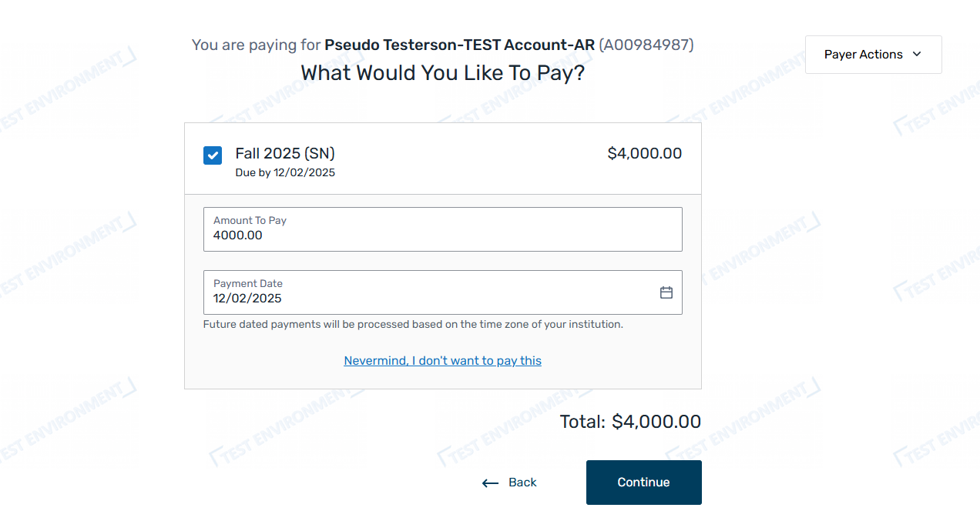

- Choose a saved credit/debit card or add a new credit/debit card. Please note that credit/debit card payments incur a 2.5% service fee. Then click Continue.
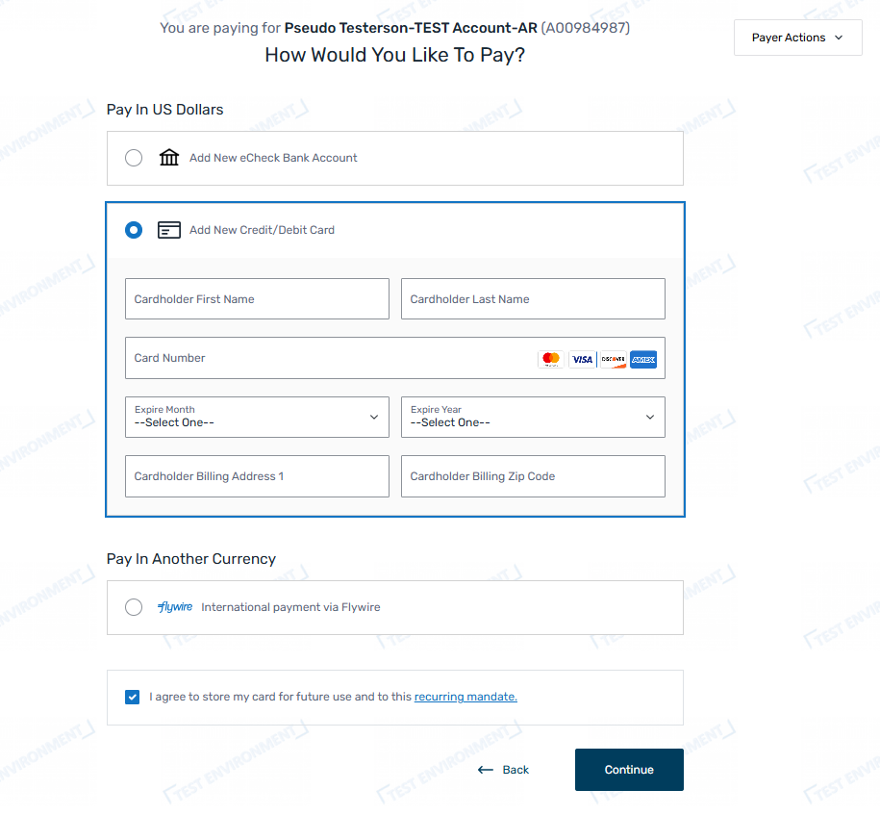
- Review the payment information and click Confirm to make the payment.
