Step 1: Visit paymybill.rutgers.edu and log in to your online term bill.
OR: Log in to the myRutgers portal and access the OTB via the My Money widget.

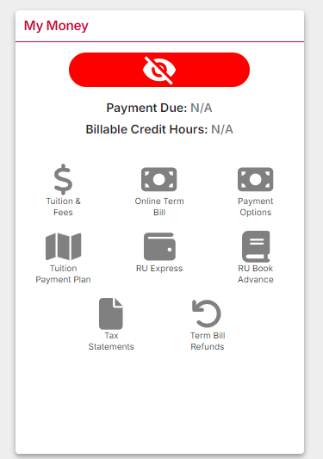

Step 2: Select the appropriate semester. Click the ‘Pay My Bill’ button found under the Outstanding Balance box.

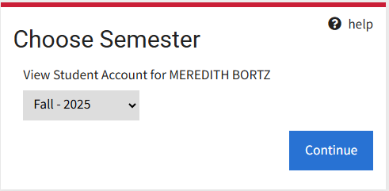
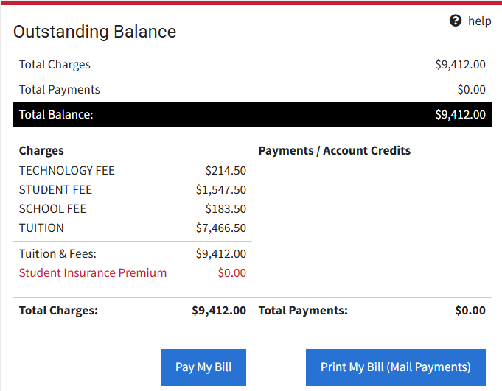

Step 3: On the Payment Adjustments screen, check any boxes that apply to your account. You can manually adjust the payment amount in the grey box, then click the ‘Verify Payment Adjustments’ button.

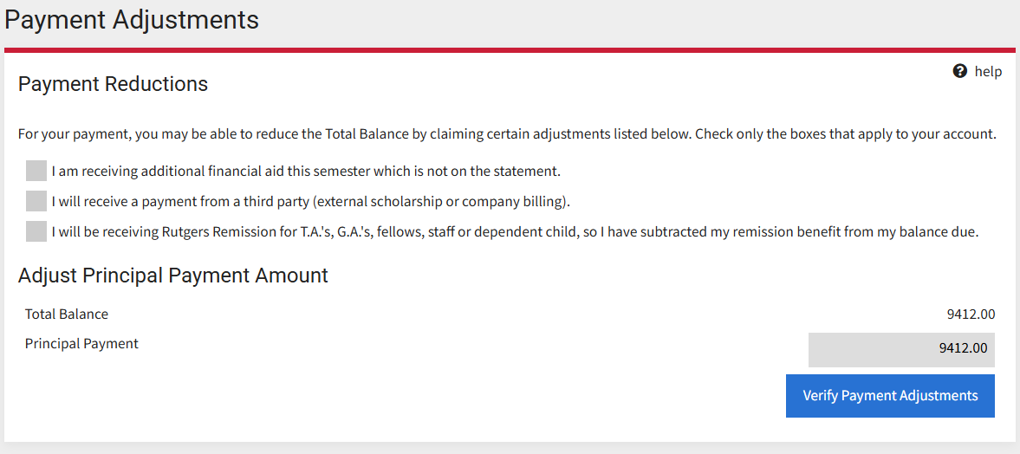

Step 4: Select the ‘Continue to Online Payment’ button to continue to Nelnet.

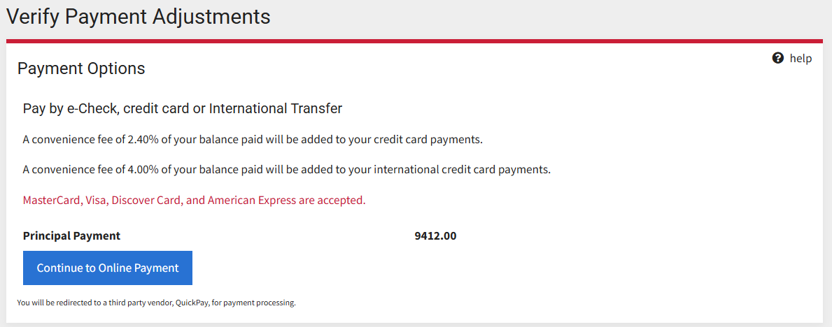

Step 5: You will be prompted to acknowledge the Refund Policy upon accessing the Nelnet QuickPay portal.
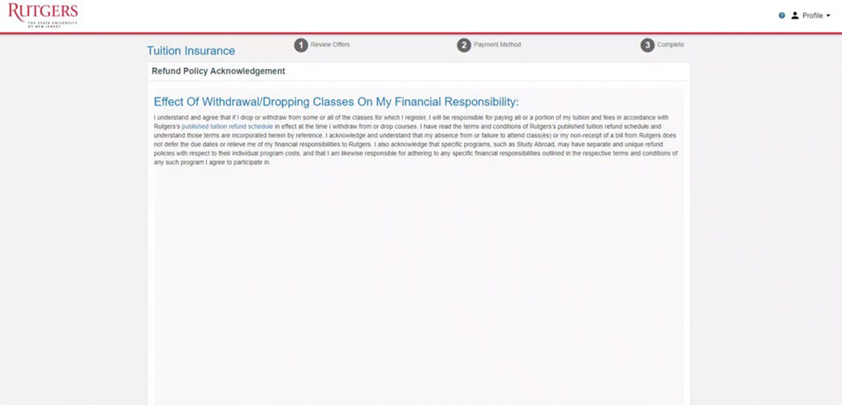

Step 6: You must then review GradGuard Tuition & Fee Protection information and choose to enroll in a plan or decline coverage. Students who choose to enroll in Tuition & Fee Protection can view complete instructions here. Tuition & Fee Protection can be purchased via e-check, credit, or debit card.

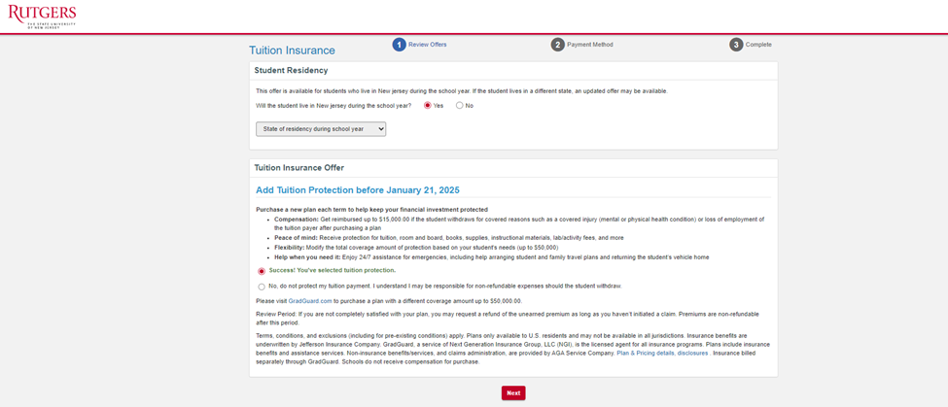

Note: If you decline at this time, you can return to the Tuition & Fee Protection tab to enroll before the deadline.
Step 7: Select Credit/Debit as the payment method. Please note that service fees apply to credit and debit card payments.

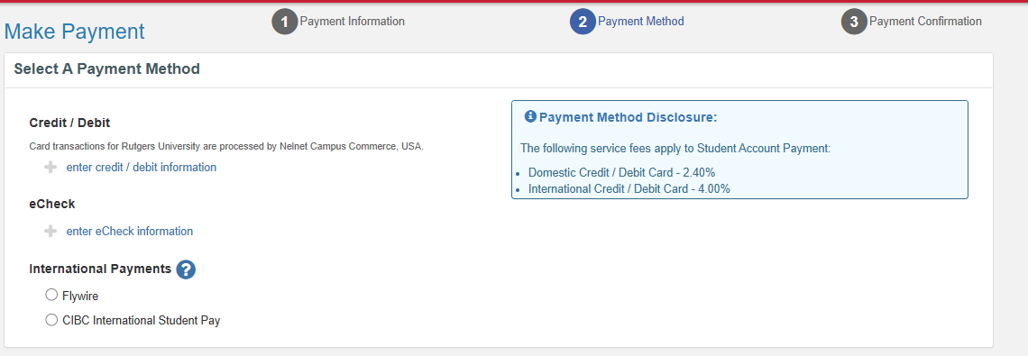

Step 8: Enter the payment information and billing address.
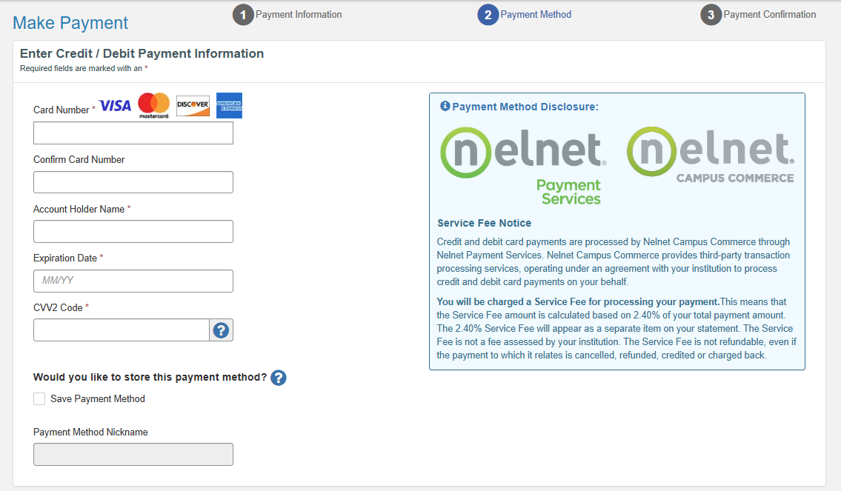
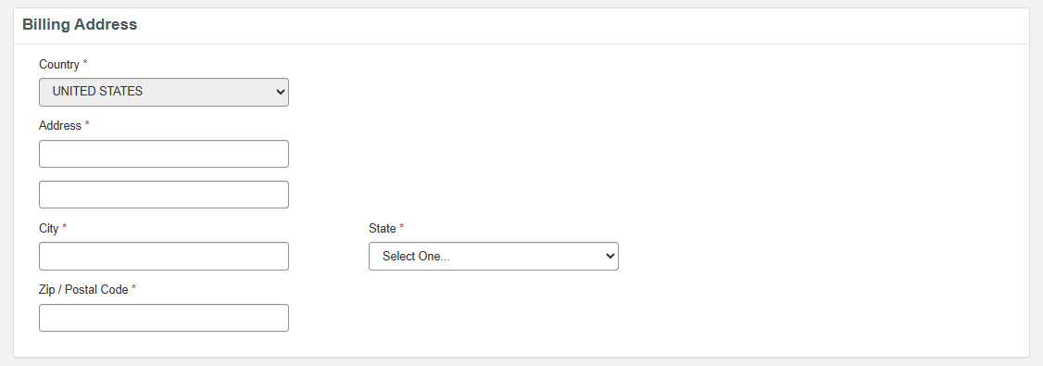

Step 9: Enter your contact information, agree to the service fee, and Submit Payment.

