Please note: These instructions do not apply to Rutgers Health payments. To pay a Rutgers Health term bill and/or related fees, please follow the Flywire instructions for Rutgers Health payments located in the Credit Cards section of the Student ABC Payment page.

Step 1: Visit paymybill.rutgers.edu and log in to your online term bill.
OR:
Log in to the myRutgers portal and access the online term bill via the My Money widget.
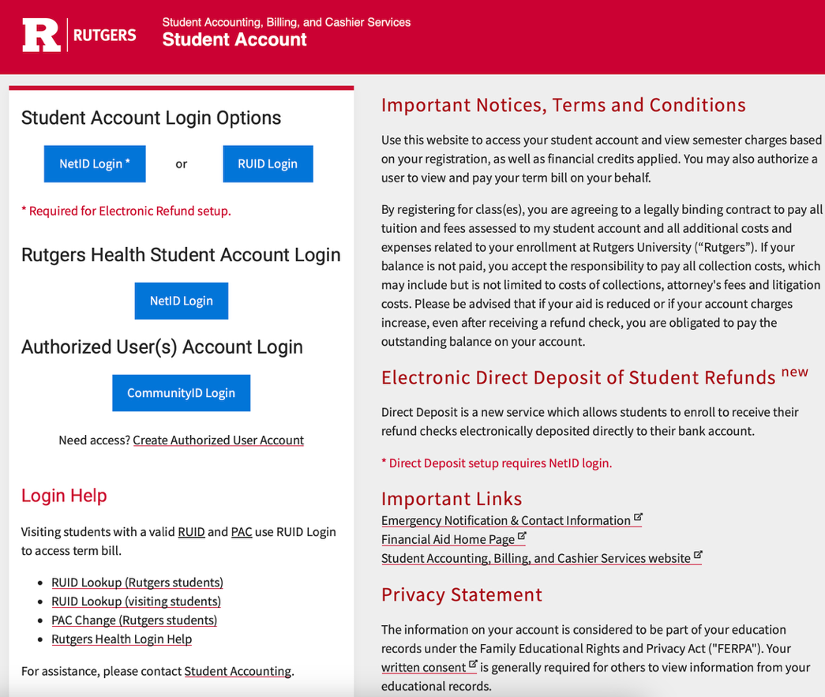
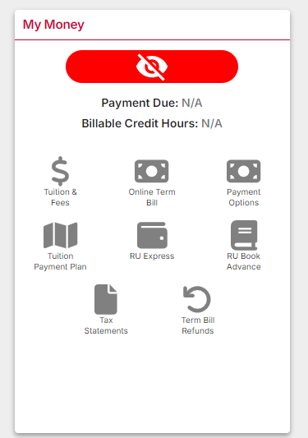

Step 2: Use the drop-down filter to select the appropriate semester and click Continue. Then click the Pay My Bill button on the Outstanding Balance screen.

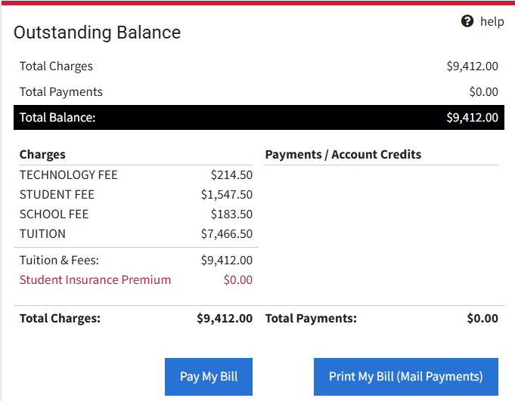
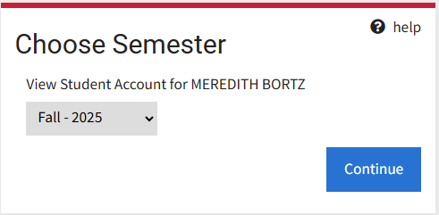

Step 3: On the Payment Adjustments screen, check any boxes that apply to your account. You can manually adjust the payment amount in the grey box, then click the Verify Payment Adjustments button.

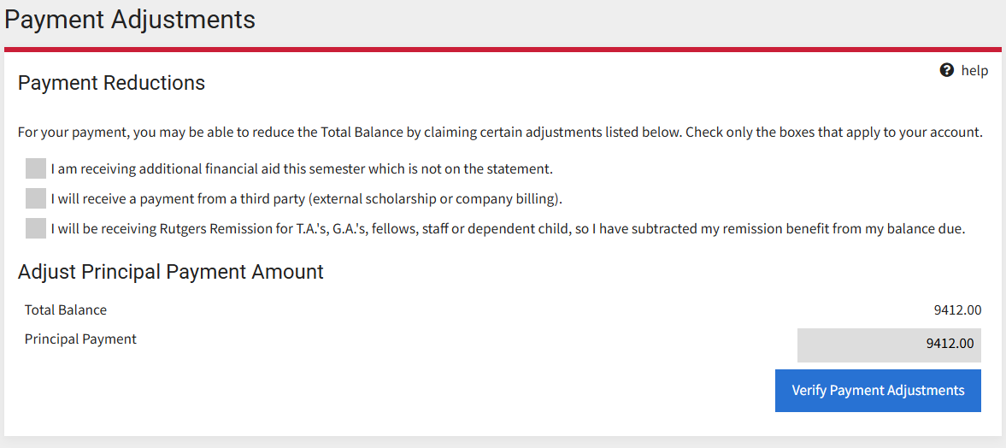

Step 4: Select the Continue to Online Payment button to continue to Nelnet QuickPay.

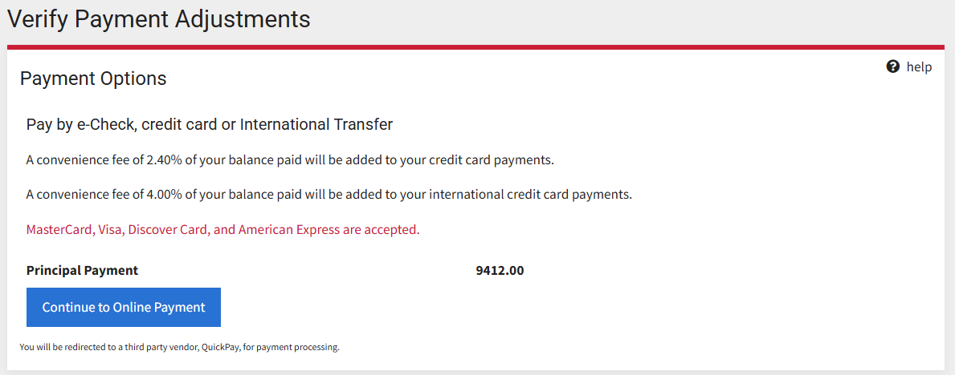
Step 5: You will be prompted to acknowledge the Refund Policy in the Nelnet QuickPay portal.
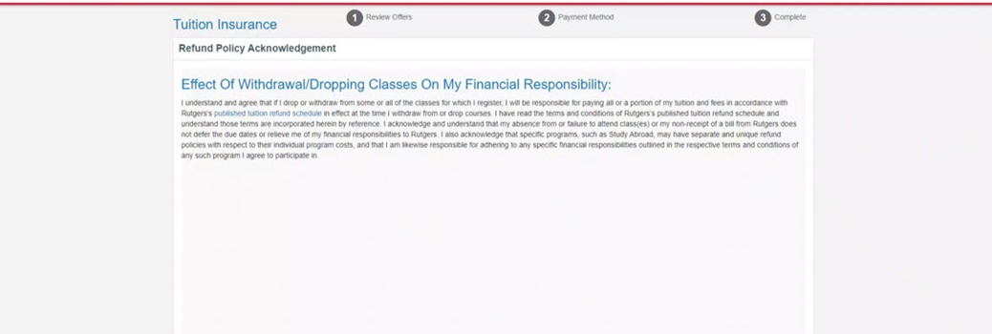

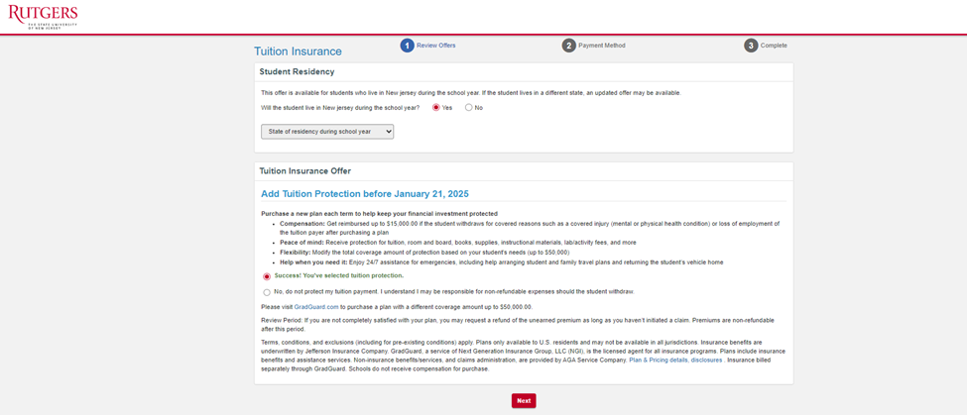
Step 6: You must then review the GradGuard Tuition & Fee Protection information and choose to either enroll in a plan or decline coverage. Tuition & Fee Protection can be purchased via e-check, or credit or debit card. View instructions for enrolling in Tuition & Fee Protection. Note: If you decline at this time, you can return to the Tuition & Fee Protection tab to enroll before the deadline.
Step 7: Select a Payment Method: credit/debit or eCheck. Please note that service fees apply to domestic and international credit/debit card payments. Note: Please visit the International Payments section of our website for instructions on making online international payments using CIBC and Flywire.

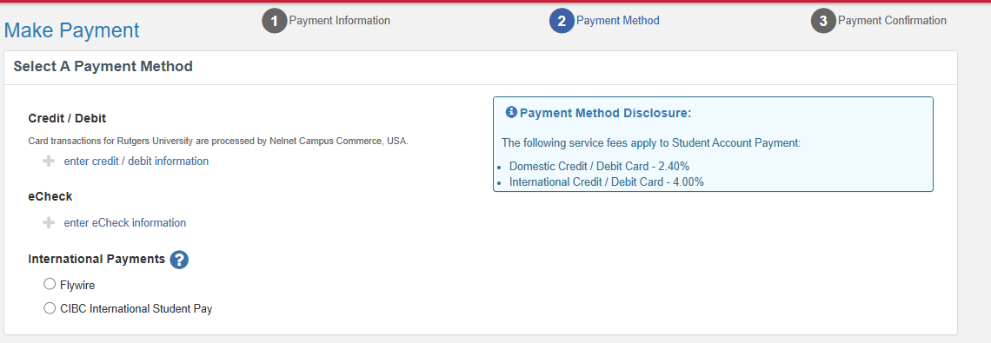

Step 8: For credit/debit card payments, you will be prompted to enter your card information. For eCheck payment, you will be asked to enter relevant bank account information.

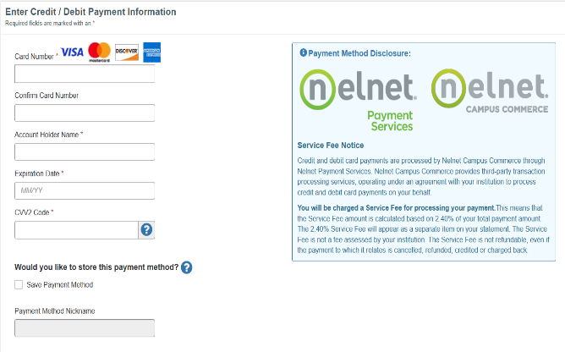
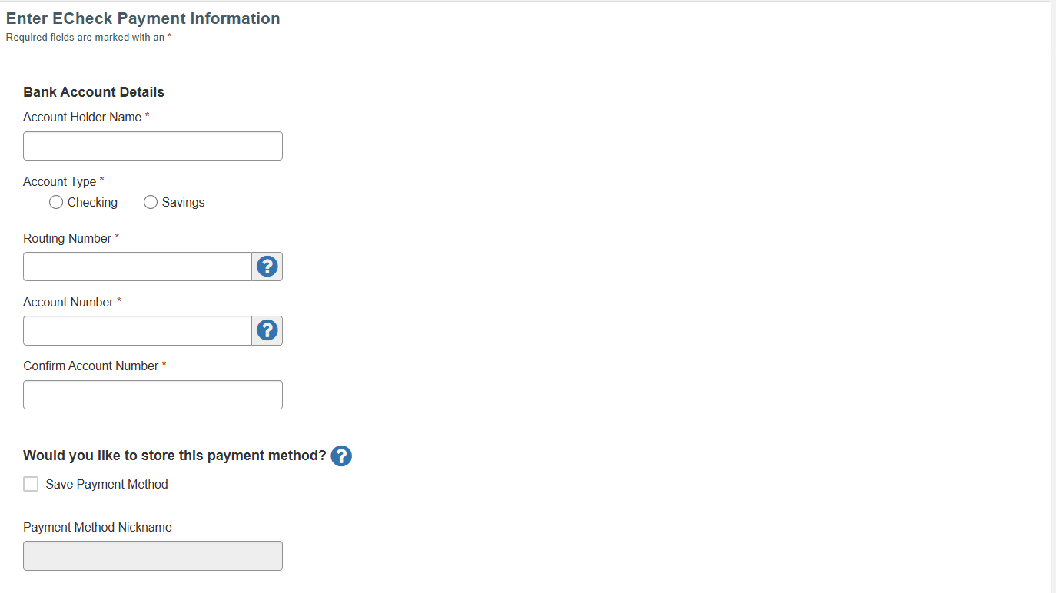

Step 9: Enter the billing address.
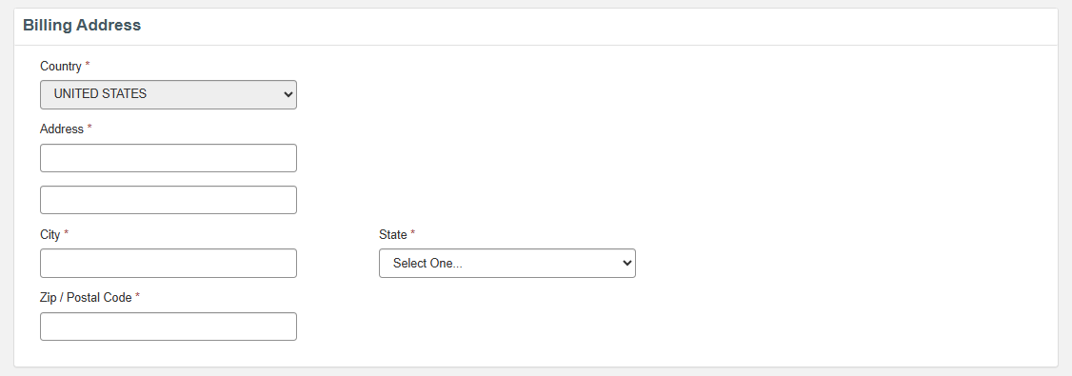

Step 10: Enter your contact information; check the box to authorize the payment; and click Submit Payment.

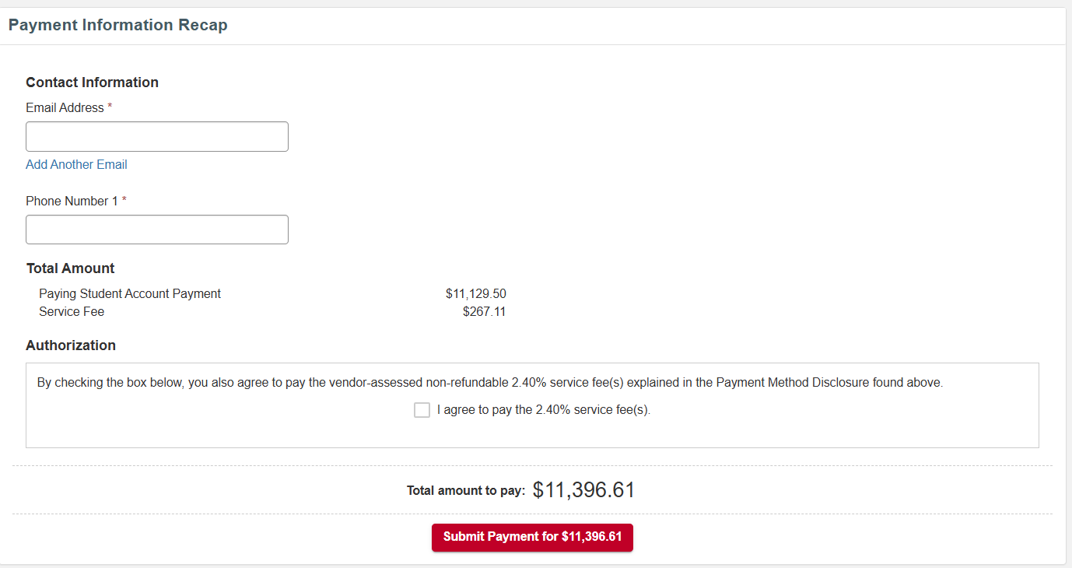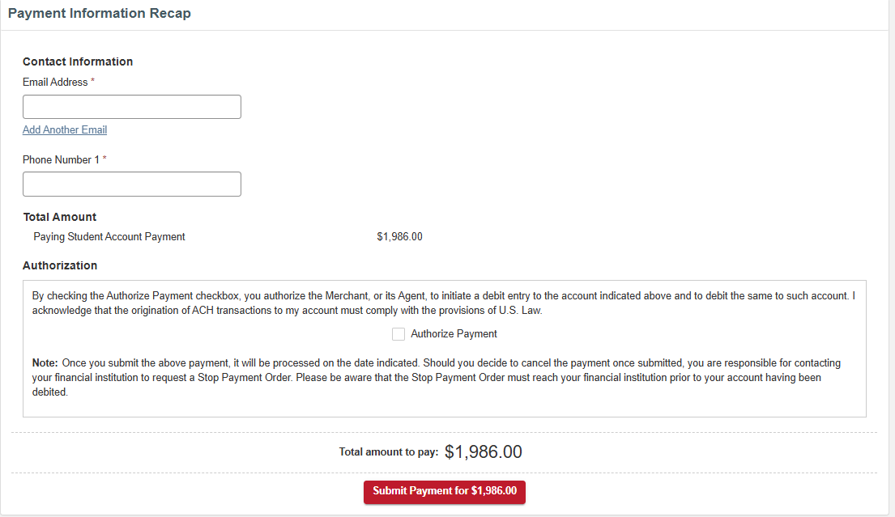
$9,412.00
$9,412.00
$9,412.00
$225.88
$9,637.88
$9,412.00

$9,637.88

